**Diving into the History of Nanotechnology**

Nanotechnology is a rapidly growing field that has the potential to revolutionize various industries, including medicine, electronics, and materials science. The history of nanotechnology can be traced back to ancient civilizations, where artisans unknowingly used nanomaterials to create intricate artwork and pottery. The modern era of nanotechnology, however, began with the visionary ideas of physicist Richard Feynman and the development of advanced imaging techniques, such as the scanning tunneling microscope.

Written below is the fascinating history of nanotechnology, its origins, significant milestones, and the potential impact on our future.

**Early Examples of Nanotechnologies**

Many early examples of nanostructured materials were based on the empirical understanding and manipulation of materials by craftsmen. These artisans often used high heat to produce materials with novel properties.

**The Lycurgus Cup**

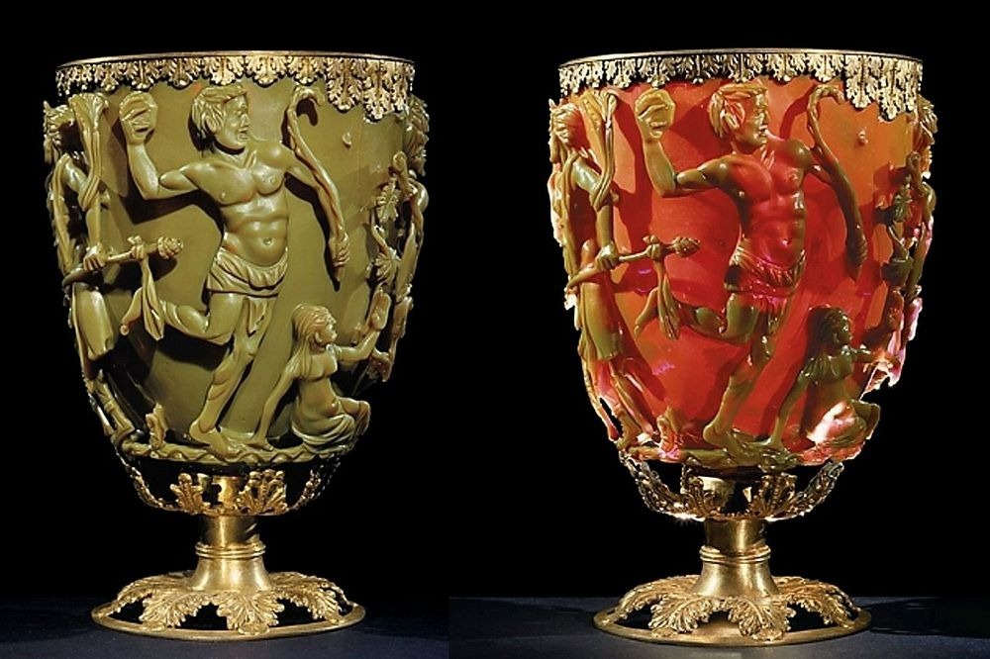

The Lycurgus Cup, dating back to the 4th century, is a prime example of dichroic glass. This Roman artifact is made from colloidal gold and silver, which allows it to appear opaque green when lit from the outside, but translucent red when light shines through the inside. This unique property is due to the nano-sized particles of gold and silver suspended within the glass.

**Luster Ceramic Glazes**



From the 9th to 17th centuries, glowing and glittering "luster" ceramic glazes were used across the Islamic world and later in Europe. These glazes contained silver, copper, or other metallic nanoparticles, which gave the ceramics their characteristic shiny appearance.

**Stained Glass Windows**



During the 6th to 15th centuries, European cathedrals showcased vibrant stained glass windows. The rich colors of these windows were due to nanoparticles of gold chloride and other metal oxides and chlorides. Interestingly, gold nanoparticles also served as photocatalytic air purifiers within the cathedrals.

**Damascus Saber Blades**

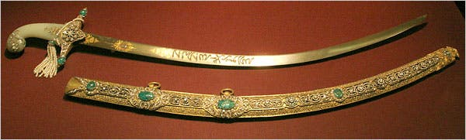

Damascus saber blades, produced between the 13th and 18th centuries, contained carbon nanotubes and cementite nanowires. This ultrahigh-carbon steel formulation provided the blades with strength, resilience, and the ability to hold a keen edge. The unique moire pattern in the steel is a distinguishing feature of these blades.

**Modern Era Discoveries and Developments in Nanotechnology**

The modern era of nanotechnology is marked by increasingly sophisticated scientific understanding, instrumentation, and experimentation.

**Colloidal "Ruby" Gold**



In 1857, Michael Faraday discovered colloidal "ruby" gold, demonstrating that nanostructured gold under certain lighting conditions produces different-colored solutions. This discovery laid the foundation for future research into the properties of nanomaterials.

**Field Emission Microscope**



In 1936, Erwin Muller invented the field emission microscope, allowing scientists to obtain near-atomic-resolution images of materials. This invention was a significant milestone in the development of nanotechnology.

**Semiconductor Transistor**



The discovery of the semiconductor transistor in 1947 by John Bardeen, William Shockley, and Walter Brattain at Bell Labs greatly expanded scientific knowledge of semiconductor interfaces. This breakthrough laid the foundation for the electronic devices and information age that we know today.

**Monodisperse Colloidal Materials**

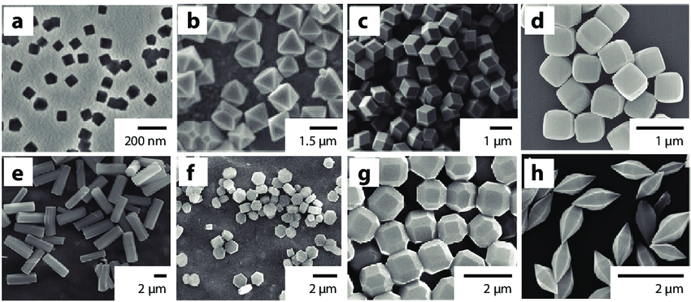

Victor La Mer and Robert Dinegar developed the theory and process for growing monodisperse colloidal materials in 1950. This controlled fabrication of colloids enabled a wide range of industrial applications, including specialized papers, paints, thin films, and even dialysis treatments.

**Field Ion Microscope**



In 1951, Erwin Muller pioneered the field ion microscope, which allowed scientists to image the arrangement of atoms at the surface of a sharp metal tip. Muller first imaged tungsten atoms using this innovative technique.

The view:



**Molecular Engineering**



In 1956, Arthur von Hippel at MIT introduced the concept of molecular engineering, which he applied to dielectrics, ferroelectrics, and piezoelectrics. This marked the beginning of nanotechnology as a distinct field of study.

**Integrated Circuit**

Jack Kilby of Texas Instruments created the first integrated circuit in 1958, for which he received the Nobel Prize in 2000. This groundbreaking invention paved the way for the miniaturization of electronic devices and the development of modern computing technology.

**Richard Feynman's Vision**



In 1959, Richard Feynman gave a seminal lecture titled "There's Plenty of Room at the Bottom" at the California Institute of Technology. This lecture, which is considered the first on technology and engineering at the atomic scale, inspired the conceptual framework for the goals of nanotechnology.

**Moore's Law**

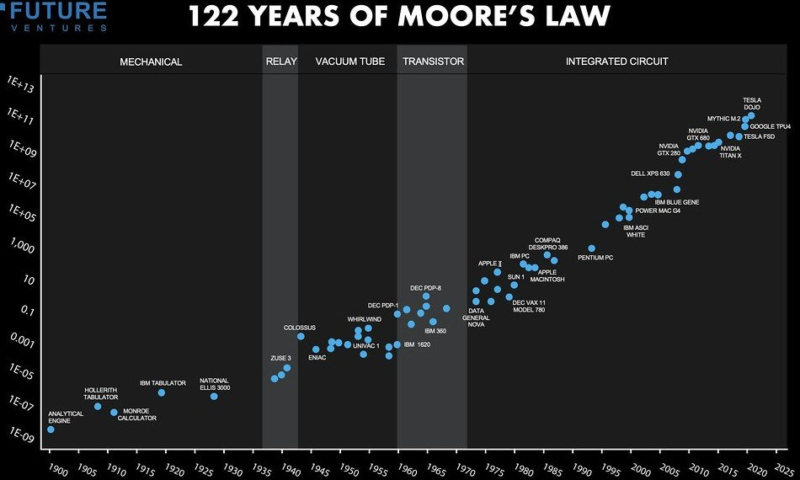

Gordon Moore, co-founder of Intel, predicted in 1965 that the density of transistors on an integrated chip would double every 12 months (later amended to every 2 years). This observation, known as Moore's Law, has held true for over 50 years, largely due to the semiconductor industry's increasing reliance on nanotechnology as integrated circuits and transistors have approached atomic dimensions.

**The Term "Nanotechnology"**

In 1974, Norio Taniguchi, a professor at Tokyo Science University, first coined the term "nanotechnology" to describe precision machining of materials within atomic-scale dimensional tolerances.

**Scanning Tunneling Microscope**

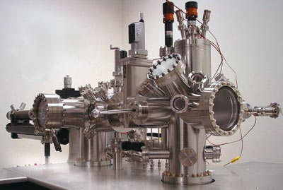

The invention of the scanning tunneling microscope (STM) in 1981 by Gerd Binnig and Heinrich Rohrer at IBM's Zurich lab allowed scientists to create direct spatial images of individual atoms for the first time. Binnig and Rohrer were awarded the Nobel Prize for this discovery in 1986.

**Quantum Dots**

In 1981, Alexei Ekimov discovered nanocrystalline, semiconducting quantum dots in a glass matrix and conducted pioneering studies of their electronic and optical properties.

**Buckyballs**

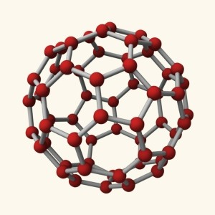

In 1985, researchers at Rice University, including Harold Kroto, Sean O'Brien, Robert Curl, and Richard Smalley, discovered the Buckminsterfullerene (C60), more commonly known as the buckyball. This molecule, composed entirely of carbon, has a soccer ball-like shape and is part of the fullerene class of molecules. The team was awarded the 1996 Nobel Prize in Chemistry for their work.

**Colloidal Semiconductor Nanocrystals**

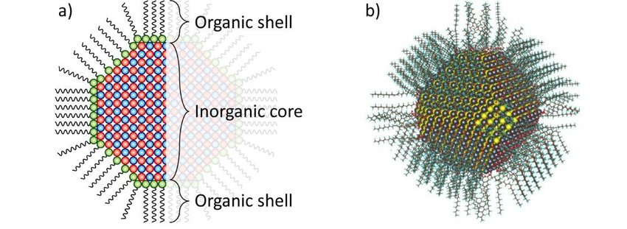

In 1985, Louis Brus from Bell Labs discovered colloidal semiconductor nanocrystals, also known as quantum dots. Brus shared the 2008 Kavli Prize in Nanotechnology for this groundbreaking discovery.

**Atomic Force Microscope**

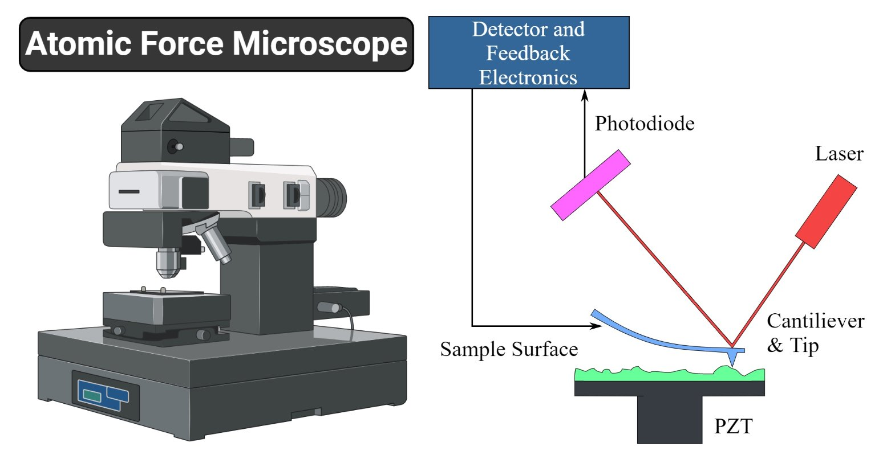

Gerd Binnig, Calvin Quate, and Christoph Gerber invented the atomic force microscope in 1986. This innovative tool allows for the viewing, measurement, and manipulation of materials down to fractions of a nanometer in size, including the measurement of various forces intrinsic to nanomaterials.

**IBM Logo Spelled with Xenon Atoms**

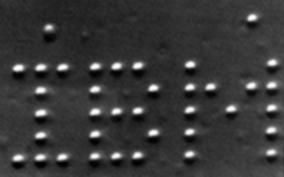

In 1989, Don Eigler and Erhard Schweizer at IBM's Almaden Research Center manipulated 35 individual xenon atoms to spell out the IBM logo. This demonstration of the ability to precisely manipulate atoms marked the beginning of applied nanotechnology.

**Early Nanotechnology Companies**

The 1990s saw the emergence of early nanotechnology companies, such as Nanophase Technologies in 1989, Helix Energy Solutions Group in 1990, Zyvex in 1997, and Nano-Tex in 1998.

**Carbon Nanotubes**

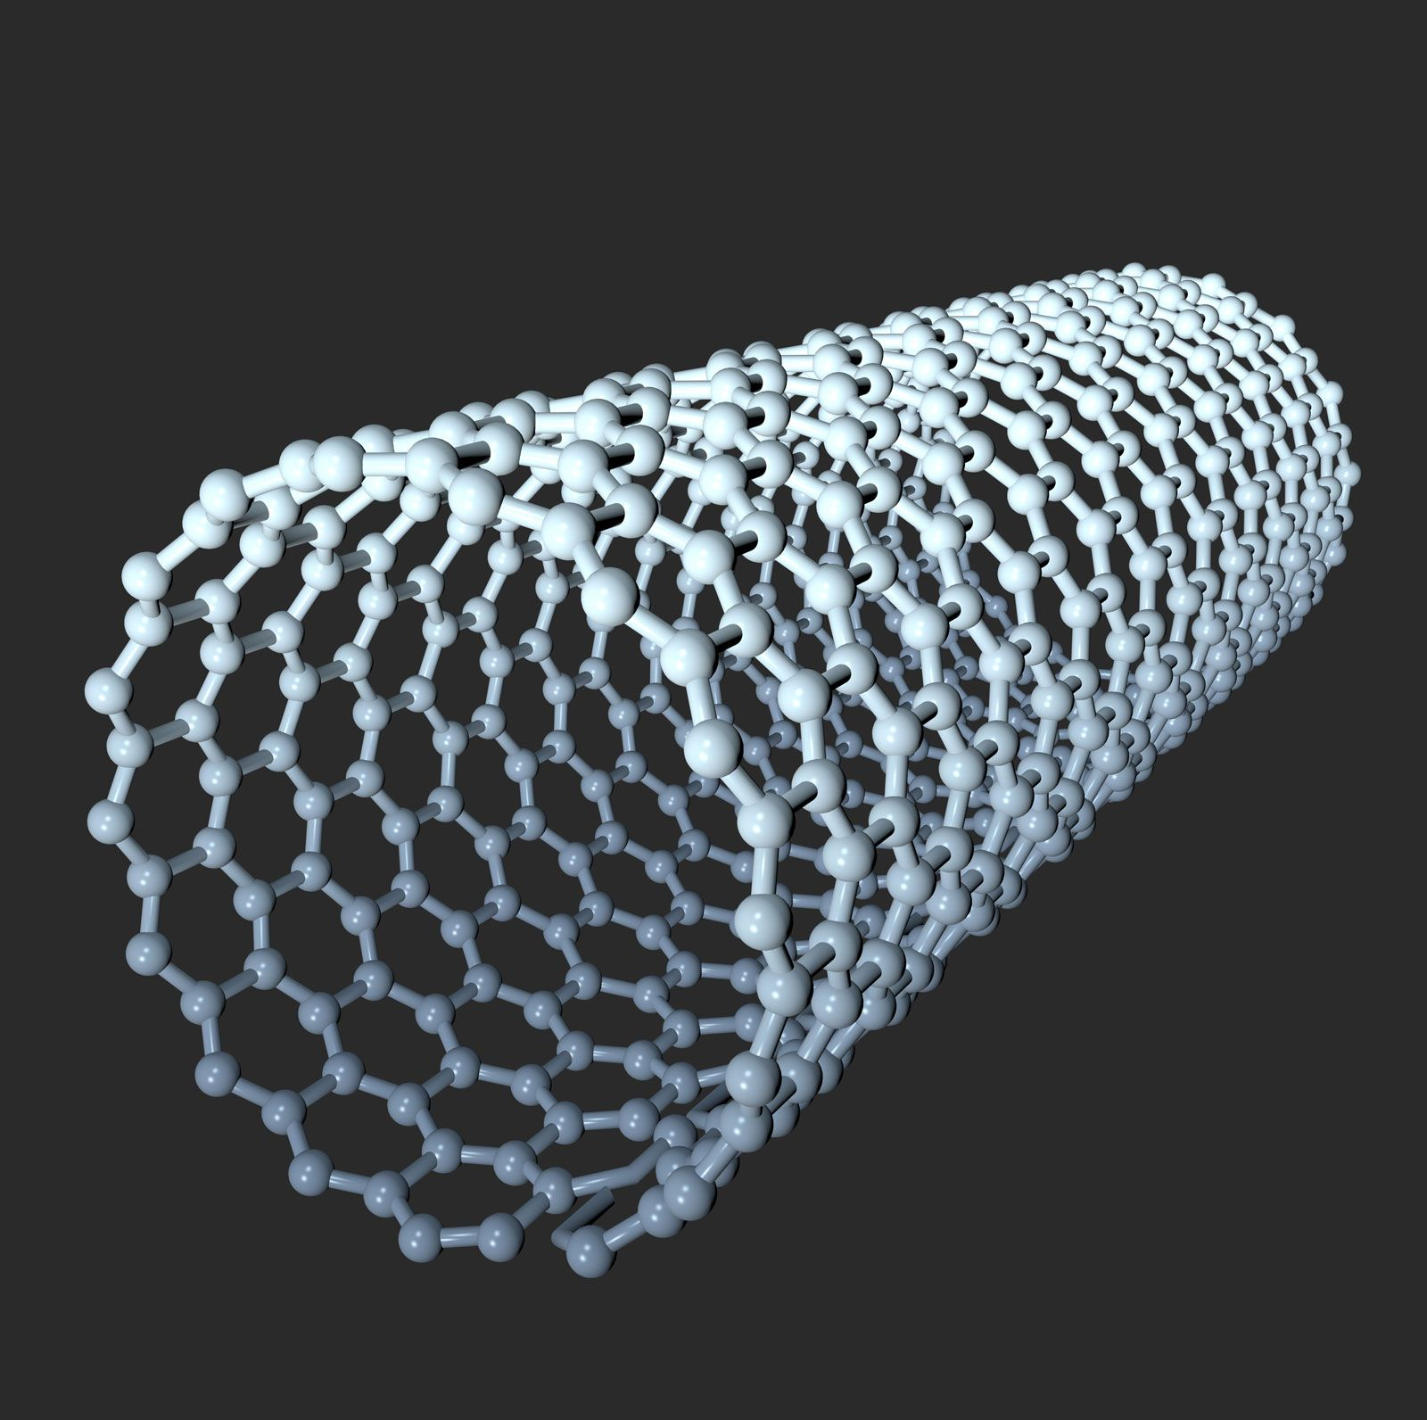

In 1991, Sumio Iijima of NEC discovered carbon nanotubes, which are tubular structures composed entirely of carbon. Carbon nanotubes exhibit extraordinary properties in terms of strength, electrical and thermal conductivity, and have been explored for various applications in electronics, photonics, multifunctional fabrics, and biology.

**Nanostructured Catalytic Materials**

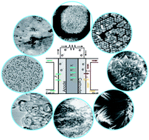

In 1992, C.T. Kresge and colleagues at Mobil Oil discovered nanostructured catalytic materials MCM-41 and MCM-48. These materials are now used extensively in refining crude oil and have other applications in drug delivery, water treatment, and more.

**Controlled Synthesis of Nanocrystals**

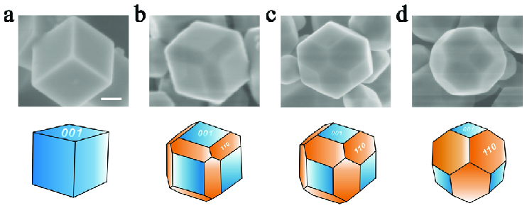

In 1993, Moungi Bawendi at MIT invented a method for the controlled synthesis of nanocrystals, paving the way for applications in computing, biology, and high-efficiency photovoltaics and lighting.

**National Nanotechnology Initiative**

 

In 2000, President Clinton launched the National Nanotechnology Initiative (NNI) to coordinate federal research and development efforts and promote U.S. competitiveness in nanotechnology.

**Gold Nanoshells**



In 2003, researchers at Rice University developed gold nanoshells, which can be tuned in size to absorb near-infrared light. These nanoshells have promising applications in the integrated discovery, diagnosis, and treatment of breast cancer without invasive biopsies, surgery, or systemically destructive radiation or chemotherapy.

**European Strategy for Nanotechnology**

In 2004, the European Commission adopted the Communication "Towards a European Strategy for Nanotechnology", which proposed institutionalizing European nanoscience and nanotechnology research and development efforts within an integrated and responsible strategy.

**College of Nanoscale Science and Engineering**

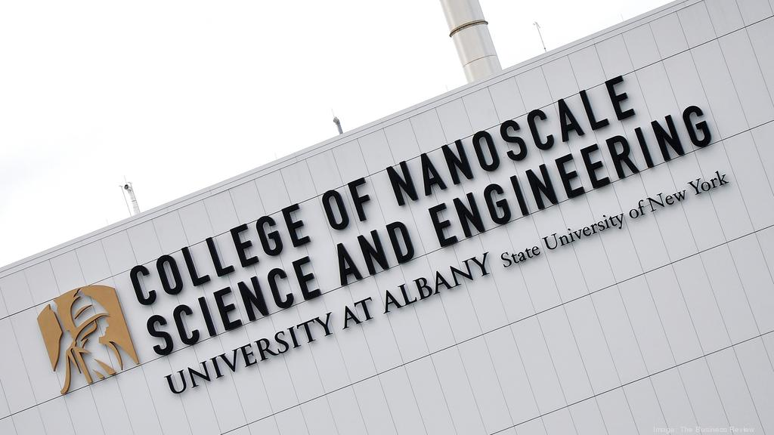

In 2004, SUNY Albany launched the first college-level education program in nanotechnology in the United States, the College of Nanoscale Science and Engineering.

**DNA-Based Computation and Algorithmic Self-Assembly**

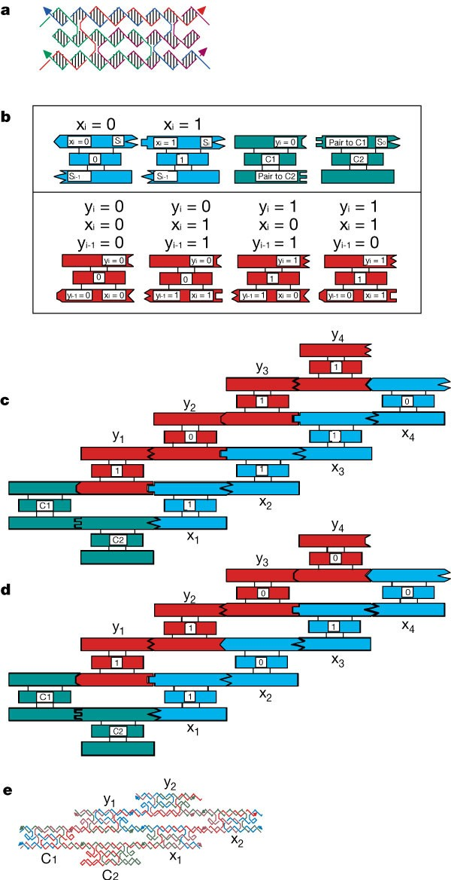

In 2005, Erik Winfree and Paul Rothemund from the California Institute of Technology developed theories for DNA-based computation and "algorithmic self-assembly". These concepts involve embedding computations in the process of nanocrystal growth, potentially revolutionizing nanoelectronics.

**Nanoscale Car**

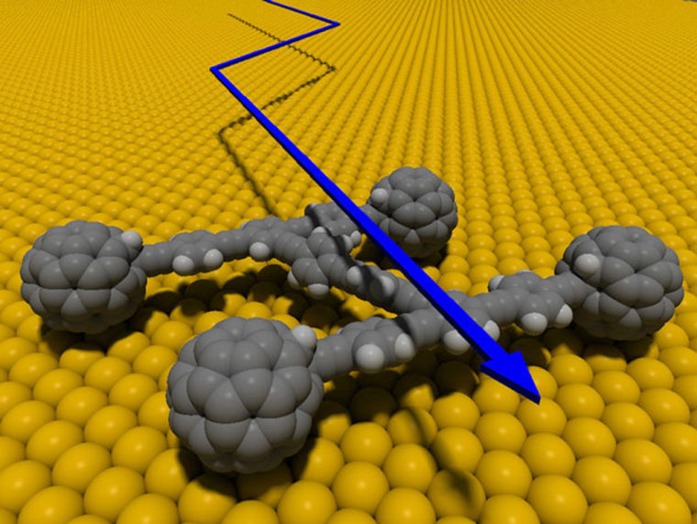

In 2006, James Tour and colleagues at Rice University built a nanoscale car made of oligo(phenylene ethynylene) with alkynyl axles and four spherical C60 fullerene (buckyball) wheels. When heated, the nanocar moved about on a gold surface due to the turning of the buckyball wheels, similar to a conventional car.

**Virus-Loaded Lithium-Ion Battery**

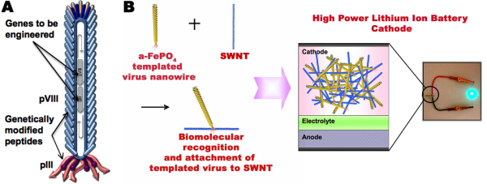

In 2007, Angela Belcher and colleagues at MIT built a lithium-ion battery using a common type of virus that is nonharmful to humans. This low-cost and environmentally benign process resulted in batteries with the same energy capacity and power performance as state-of-the-art rechargeable batteries being considered for use in plug-in hybrid cars and personal electronic devices.

**Nanosensors and Nanotechnology Knowledge Infrastructure**

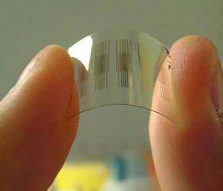

In 2012, the NNI launched two more Nanotechnology Signature Initiatives (NSIs), focusing on nanosensors and the Nanotechnology Knowledge Infrastructure (NKI).

**DNA-Like Robotic Nanoscale Assembly Devices**

 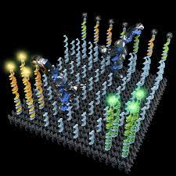

In 2009 and 2010, Nadrian Seeman and colleagues at New York University created several DNA-like robotic nanoscale assembly devices, which have potential applications in electronics, photonics, and biology.

**The Future of Nanotechnology**



Nanotechnology continues to make significant strides in various fields, promising to revolutionize industries and improve our quality of life. As our understanding of nanoscience and nanotechnology grows, so too does the potential for new applications in medicine, electronics, materials science, and beyond. The future of nanotechnology is undoubtedly bright, and its impact on our world will be profound.